

**Rizvi College Of Engineering**

#### Department Of Computer Engineering Mini Project Report

On

### Dairy Farm Shop Management System

#### Third year of Engineering By

Adnan Shaikh (38) Ameen M. Ali (03) Faisal Sayed (36) Asif Lohar (24)

#### Guide:

#### Prof. Mansi Shah.

UNIVERSITY OF MUMBAI (2020-2021)



**1**

# Content

Title

1.

2.

3.

4.

5.

Page No. 4

6

8

10

12

6.

7.

8.

9.

Abstract Introduction Literature Survey Requirement Implementation

* 1. ER Diagram
  2. ER to RD
  3. Schema
  4. Query UI Design Conclusion Acknowledgement Reference

20

26

28

29



**2**

**List of Figures**

Sr.

No.

5.1

5.2

Title

ER Diagram

ER TO RD DIAGRAM

Page No. 13

14



**3**

# Abstract

### Dairy Farm Shop Management System:

This project deals with the management of milk and milk products. It deals with the sale of milk and milk products and by making records in the database. The first step in the project is to add a staff member to the database the make entries by specifying the product type and rates with quantity, these added values will be displayed in the stock section and sales made in the transaction section. All create, read, update and delete operations are supported in this project for complete representation.

Our Shop Management System allows to view the details of the sales. It contains the information of the stocks and sales.

Customer, Products, Billing Generation: Automate the current manual bill generation system and maintain the searchable customer, products database and product invoice, maintain the data security, user rights.



**4**

Chapter 1 Introduction



**5**

### Introduction

This project deals with the management of the Computerized Dairy Farm Sho Management Solution.

The aim is to automate its existing manual system by the help of computerized equipment’s and full-fledged computer software, fulfilling their requirements, so that their valuable data/information can be stored for a longer period with easy accessing and manipulation of the same. Basically, the project describes the goods information of their efficiency cost. For easy and convenient processing, we developed a software which works as per our requirements. While preparing this software we got to remember few things i.e. this software must have a friendly environment, in other words it should not be much complicated to handle, it should have options for future modifications in the database i.e. the goods list & new items.

For smooth functioning, we had to prepare a database by which we could enter the required data in their respective locations. In this database all the records of daily entry made are stored, so that we can use them in future whenever allotted to their caretaker. Other than that, no one could use this and on entering an illegal password or login name an error message get displayed



**6**

## Chapter 2

Literature Review



**7**

### Literature Review

##### Existing System:

The existing comprises of old-school transaction dealings and does not have any digital records of the transaction. This method is highly volatile as the records could be easily lost due to human error and could cause a variety of problems. Our solution is to make the system digital and automated to reduce the labour hours and nullify human errors as much as possible.

##### Proposed system:

Proposed system is an automated Dairy Farm Shop Management System. In this System admin can login, add company, products, admin can view from which company we have purchased which products, can check payment. Admin can login, can see the record how much sale has been made and also track the record of all types of transactions at our fingertips. Our proposed system has following advantage:

* + - User friendly interface
    - Fast access to database
    - Less error
    - More Storage Capacity
    - Search facility
    - Look and Feel Environment



**8**

## Chapter 3 Requirement Analysis



**9**

* 1. **Hardware Requirements:**

1. **Requirement Analysis**

Below is the hardware we required to build the system

* 1. Pentium core2Duo or above processor
  2. 2GB RAM
  3. 320GB HDD
  4. Ethernet Port/ Wi-Fi card.

##### Software Requirements:

* + 1. Front-End:

The software required to design the user interface and user experience i.e. front end given below

* + - 1. PHP: Hypertext Pre-processor is widely used open source general-purpose scripting language that is specially suited for web development and can be embedded into html.
      2. XAMPP: for database storing.
      3. VS Code: we used this software to mainly edit and integrate webpages based on PHP, HTML and JavaScript.
    1. Backend:

The main backend technology is used for storing and managing databases is a MYSQL that provides online database storage options along with “phpMyAdmin”. MYSQL is the programming language used for backend.



**10**

##### Feasibility Study:

On this phase we describe the key topics like whether it is important by the customer and developer’s point of view to develop project or not. It is primary investigation that we take before starting the project processes. This gives us a fair idea about what? Why? and how? We will develop this project.

* + 1. Operational feasibility

We took this investigation to understand the market and get the fair knowledge about “is this application really needed?” User acceptance is the key point which is always needed while doing it. People needed much functionality from which we managed to make main functionalities available

* + 1. Economic feasibility

Economic feasibility is the most important and frequently used method for evaluating. The effectiveness of the proposed system. It is very essential because the main goal of the proposed system is to have economically better result along with increased efficiency. Cost benefit analysis is usually performed for this purpose. It is the comparative study of the cost verses the benefit and saving that are expected from the proposed system.

* + 1. Technical Feasibility

The main consideration is to be given to the study of available resources of the organization where the software is to be implemented.



**11**

## Chapter 4 Implementation



**12**

### ER DIAGRAM

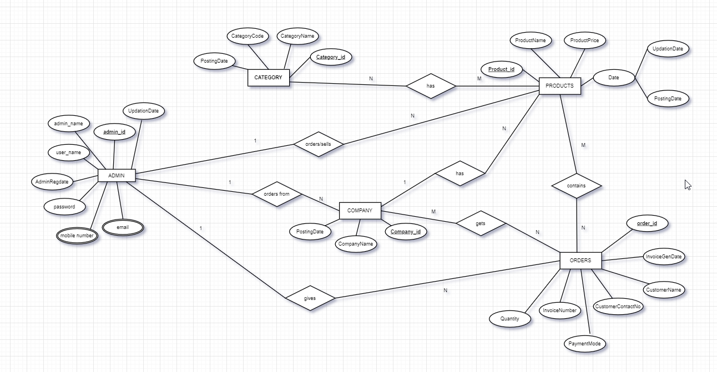



**13**

* 1. **ER TO RD DIAGRAM:**

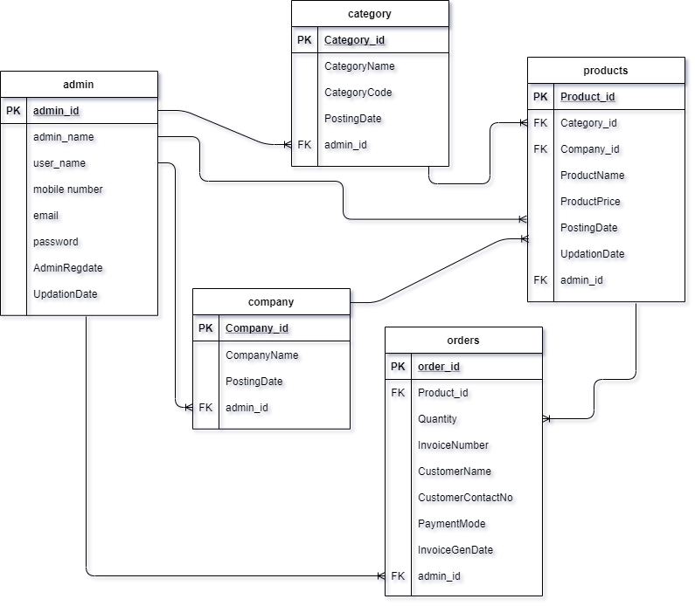



**14**

### SCHEMA

1. Admin: admin-id (pk), admin_name, user_name, mobile number, email, password, adminRegdate, UpdationDate.
2. Company: company_id (pk), company_name, PostingDate, admin_id(fk).
3. Category: category_id(pk), CategoryName, CategoryCode, PostingDate, admin_id(fk).
4. Orders: order_id(pk), Quantity, InvoiceNumber, CustomerName, CustomerContactNo, PaymentMode, InvoiceGenDate, Product_id (fk1), action,admin_id(fk2).
5. Products: product_id(pk), ProductName, ProductPrice, PostingDate, UpdationDate, Category_id(fk1), Company_id(fk2), admin_id(fk3).



**15**

### 4.5 Query

##### Create database:

Create database dfsms;

##### Create table admin:

CREATE TABLE `tbladmin` (

`ID` int(5) NOT NULL,

`AdminName` varchar(45) DEFAULT NULL,

`UserName` char(45) DEFAULT NULL,

`MobileNumber` bigint(11) DEFAULT NULL,

`Email` varchar(120) DEFAULT NULL,

`Password` varchar(120) DEFAULT NULL,

`AdminRegdate` timestamp NULL DEFAULT current_timestamp(),

`UpdationDate` timestamp NULL DEFAULT NULL ON UPDATE current_timestamp()

) ENGINE=InnoDB DEFAULT CHARSET=latin1;

##### Create table Category:

CREATE TABLE `tblcategory` (

`id` int(11) NOT NULL,

`CategoryName` varchar(200) DEFAULT NULL,

`CategoryCode` varchar(50) DEFAULT NULL,

`PostingDate` timestamp NULL DEFAULT current_timestamp()

) ENGINE=InnoDB DEFAULT CHARSET=latin1;

##### Create table tblcompany:

CREATE TABLE `tblcompany` (

`id` int(11) NOT NULL,

`CompanyName` varchar(150) DEFAULT NULL,

`PostingDate` timestamp NULL DEFAULT current_timestamp()

) ENGINE=InnoDB DEFAULT CHARSET=latin1;



**16**

##### Create table Orders:

CREATE TABLE `tblorders` (

`id` int(11) NOT NULL,

`ProductId` int(11) DEFAULT NULL,

`Quantity` int(11) DEFAULT NULL,

`InvoiceNumber` int(11) DEFAULT NULL,

`CustomerName` varchar(150) DEFAULT NULL,

`CustomerContactNo` bigint(12) DEFAULT NULL,

`PaymentMode` varchar(100) DEFAULT NULL,

`InvoiceGenDate` timestamp NULL DEFAULT current_timestamp()

) ENGINE=InnoDB DEFAULT CHARSET=latin1;;

##### Create table Products:

CREATE TABLE `tblproducts` (

`id` int(11) NOT NULL,

`CategoryName` varchar(150) DEFAULT NULL,

`CompanyName` varchar(150) DEFAULT NULL,

`ProductName` varchar(150) DEFAULT NULL,

`ProductPrice` decimal(10,0) DEFAULT current_timestamp(),

`PostingDate` timestamp NOT NULL DEFAULT current_timestamp() ON UPDATE current_timestamp(),

`UpdationDate` timestamp NULL DEFAULT NULL ON UPDATE current_timestamp()

) ENGINE=InnoDB DEFAULT CHARSET=latin1;



**17**

4.5 database structure: Admin table:

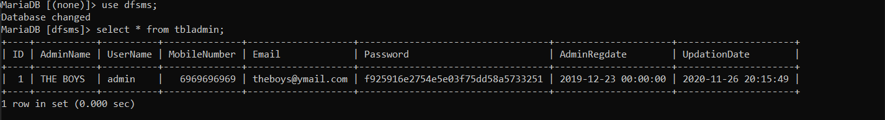

Category table:

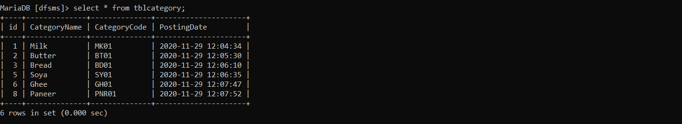

Company table:

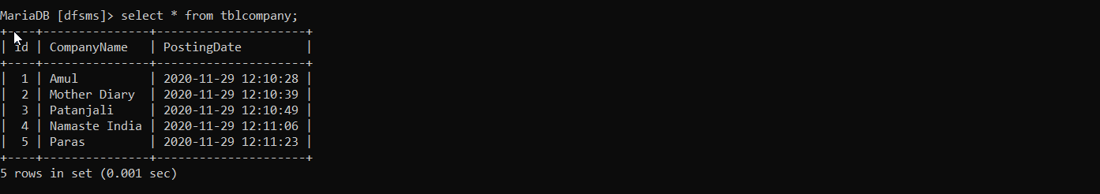

Orders table:

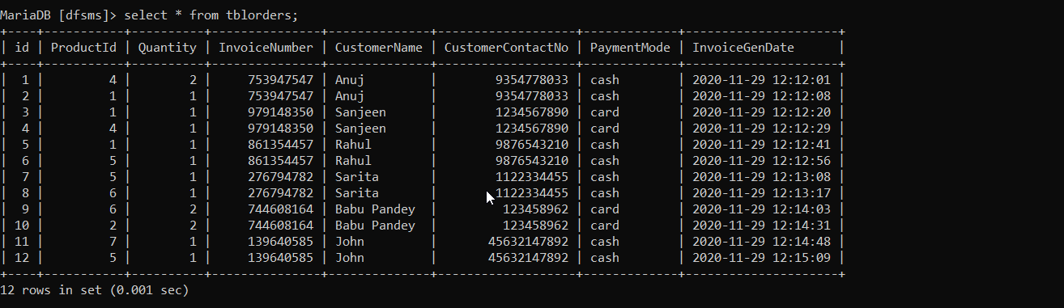



**18**

Products table:

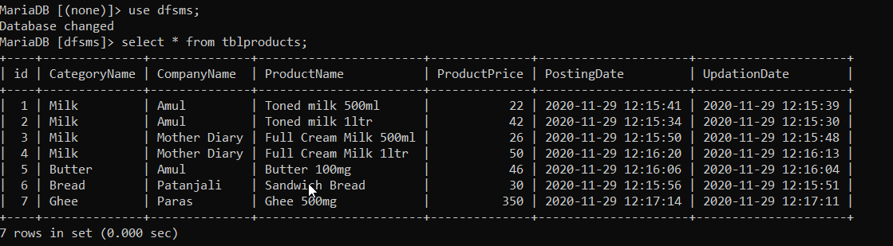



**19**

## Chapter5 UI DESIGN



**20**

**LOGIN PAGE**: 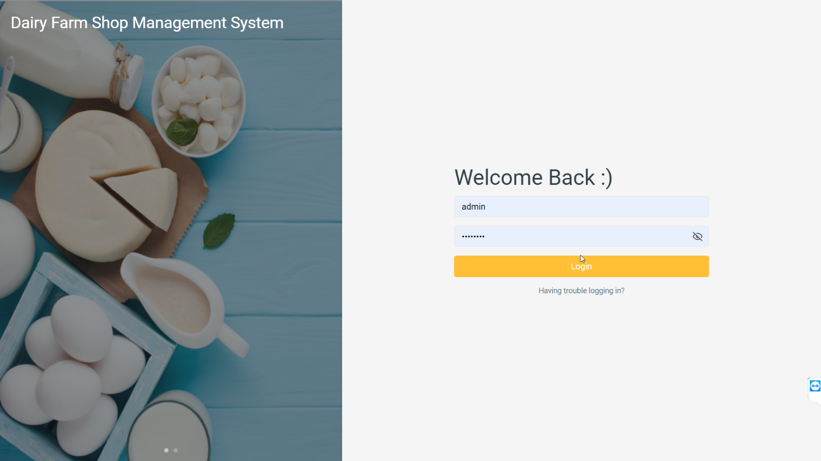

**DASHBOARD PAGE:**

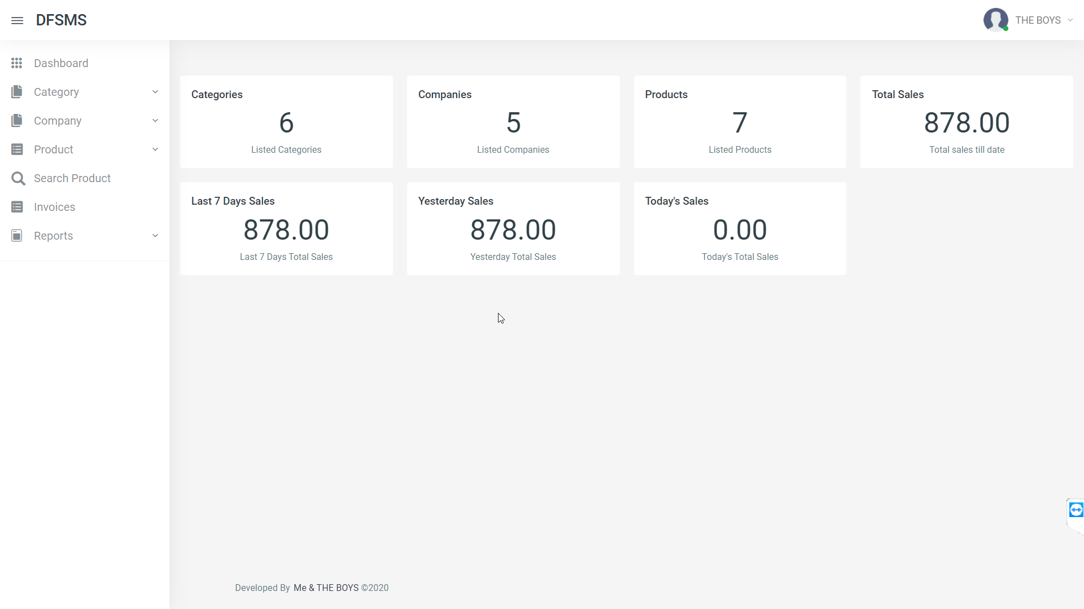



**21**

**CATEGORY-MANAGE PAGE:**

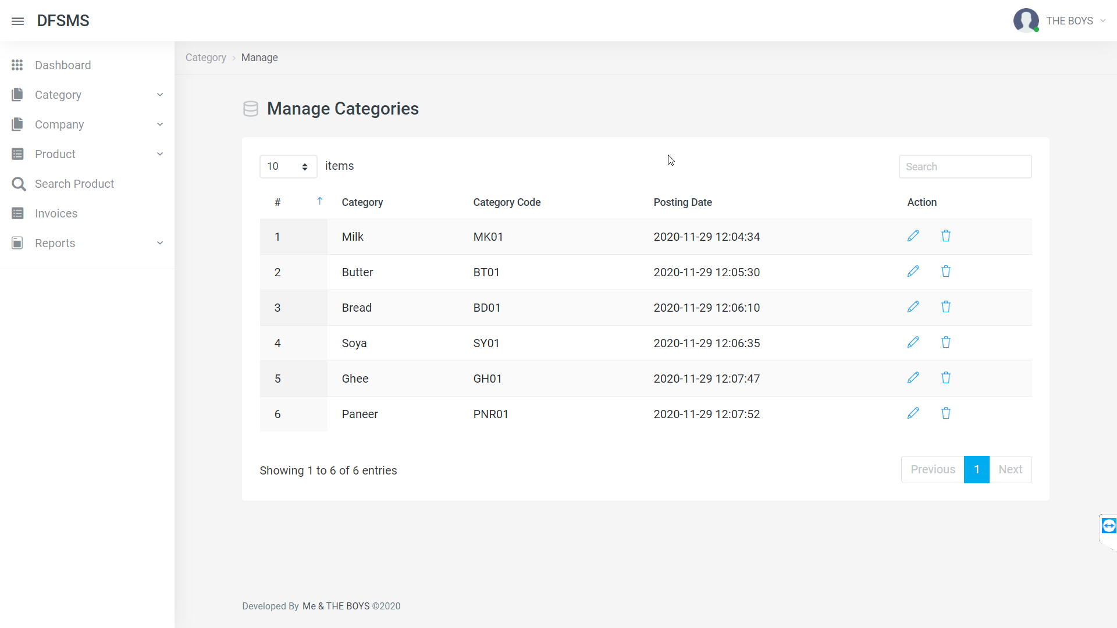

**CATEGORY-ADD PAGE:**

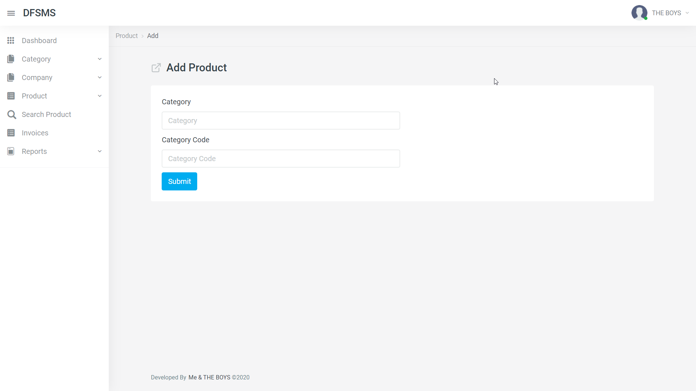



**22**

**COMPANY-MANAGE PAGE:**

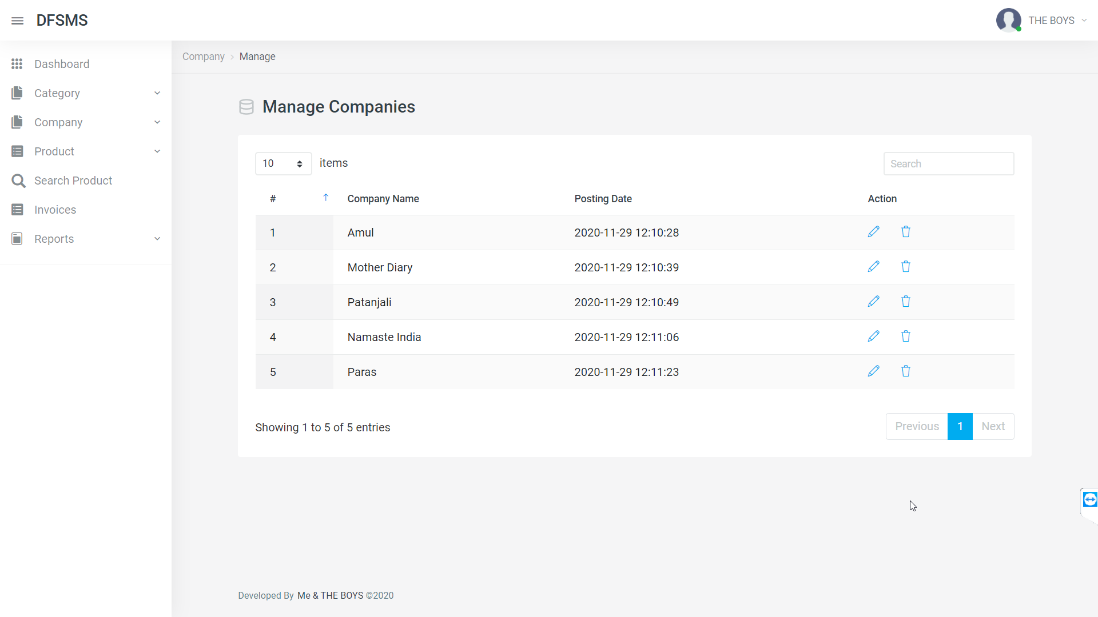

**COMPANY-ADD PAGE:**

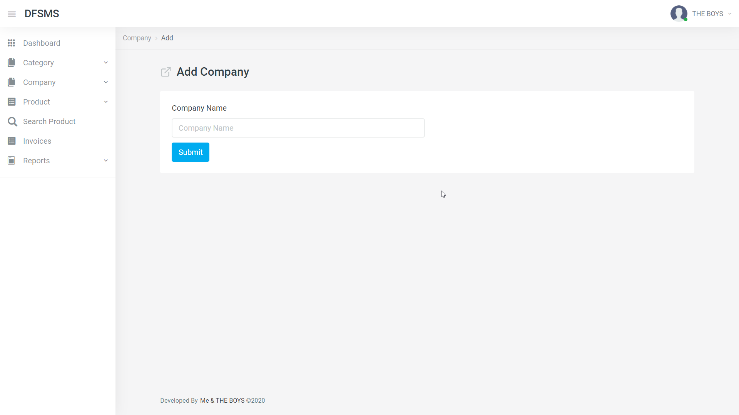



**23**

**PRODUCTS-MANAGE PAGE:**

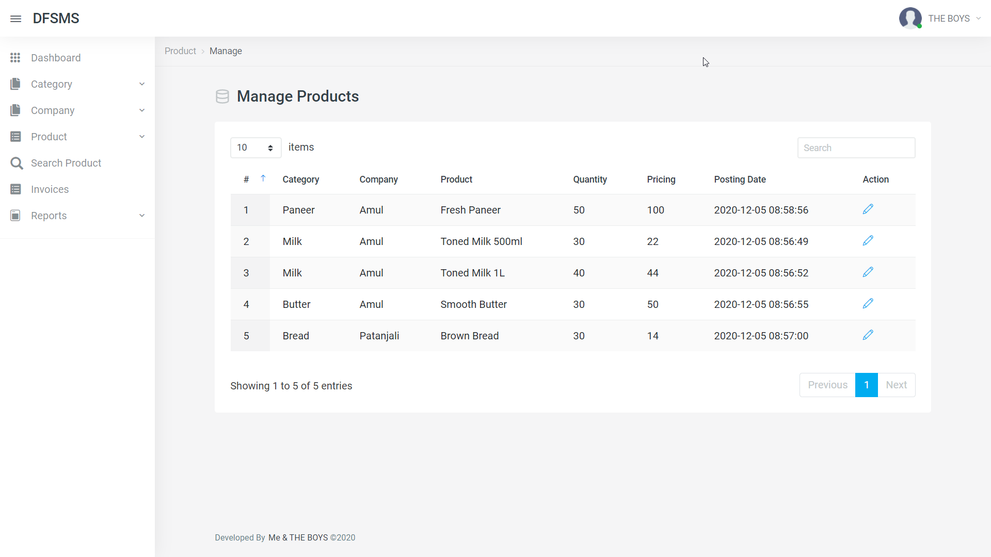

**PRODUCTS-ADD PAGE:**

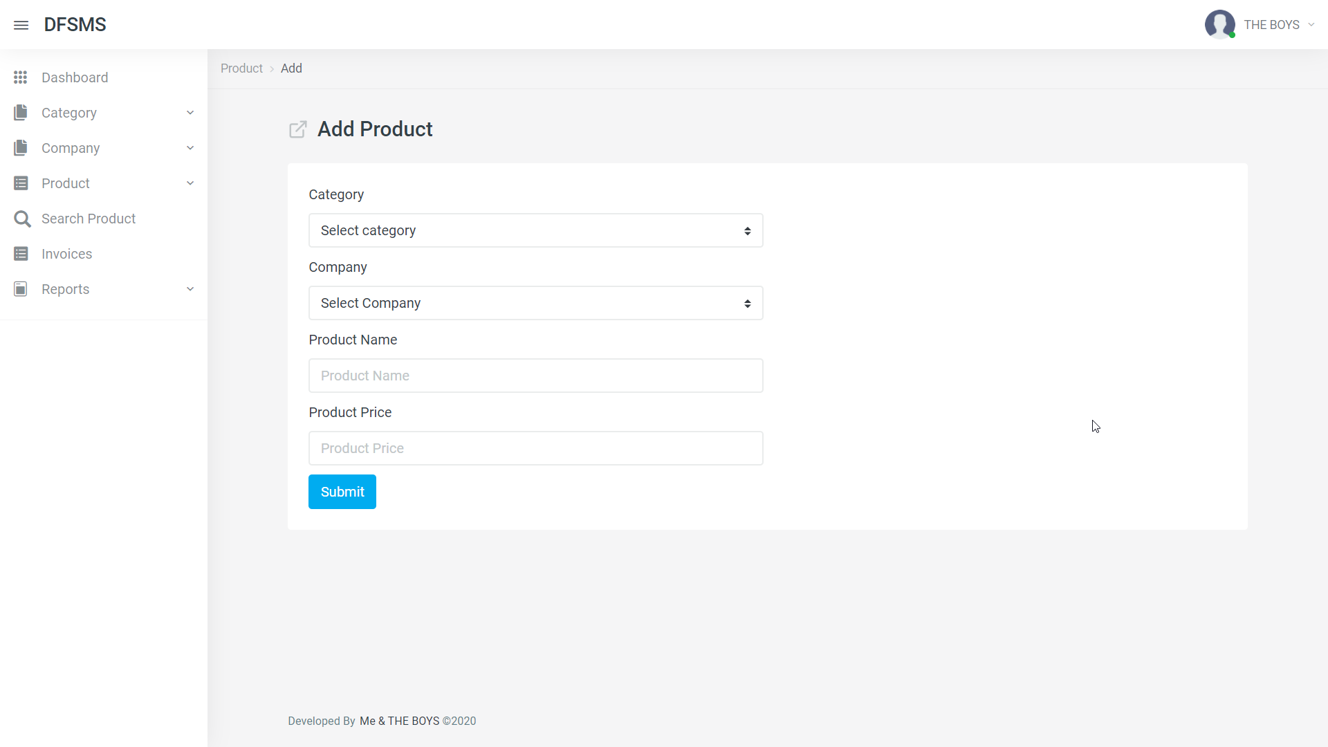



**24**

## **SEARCH-PRODUCTS PAGE:**

## 

## **CART (AFTER ADDING) PAGE:**

## 



**25**

## **INVOICES GENERATED PAGE:**

## 

## **EACH INVOICE PAGE:**

## 



**26**

## Chapter 6 Conclusion



**27**

#### Conclusion

The evidence gathered in this report reflects ongoing progress toward more openness in Shop automation systems, but also that much work remains. We see a variety of options and opportunities. Shops that expect to work with their automation system as delivered and not become involved in local extensions or programming will find that the majority of systems were built for that kind of use. For Shops that want to do more with their automation systems, however, we see a great deal of functionality possible today through open interfaces with momentum toward creating much more.



**28**

#### ACKNOWLEDGEMENT

The satisfaction that accompanies that the successful completion of any task would be incomplete without the mention of people whose ceaseless cooperation made it possible, whose constant guidance and encouragement crown all efforts with success.

We are grateful to our subject teacher Prof. Mansi Shah. for the guidance, inspiration and constructive suggestions that helpful us in the preparation of this project.

AMEEN M. ALI

(181P003)

ASIF LOHAR

(181P024)

FAISAL SAYED

(181P036)

ADNAN SHAIKH

(181P038)



**29**

REFERENCE

* + 1. <https://www.w3schools.com/sql/>
    2. <https://www.tutorialspoint.com/sql/index.htm>
    3. https://developer.mozilla.org/en-US/
    4. Book: Fundamentals of Database Systems, Elmasri Navathe Pearson Education.



**30**